
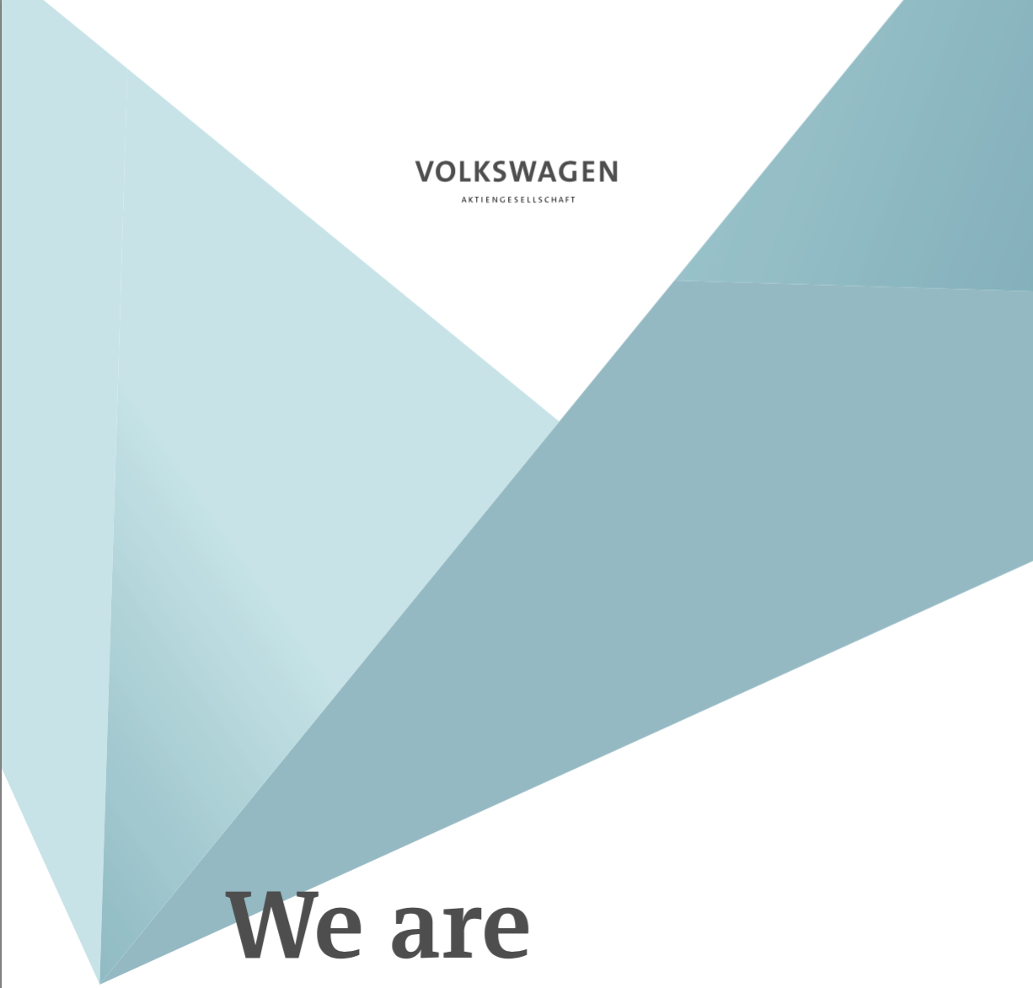

Formal Report 2017
TABLE OF CONTENTS

EXECUTIVE SUMMARY - 2 -
INTRODUCTION - 3 -
CORPORATE SOCIAL RESPONSIBILITY - 3 -
Importance of Corporate Social Responsibility - 3 -
BUSINESS ETHICS - 4 -
Business Ethics and Corporate Social Responsibility - 4 -
VOLKSWAGEN GROUP: CORPORATE SOCIAL RESPONSIBILITY AND SCANDAL - 5 -
Volkswagen Group Corporate Social Responsibility - 5 -
Volkswagen Group Emissions Scandal - 5 -
PROPOSAL FOR VOLKSWAGEN GROUP - 6 -
Solutions - 6 -
Benefits - 6 -
CONCLUSION - 6 -

EXECUTIVE SUMMARY

This report provides an overview of corporate social responsibility and business ethics as well as a description and explanation of the Volkswagen Group emissions scandal. Methods of research include various articles and books found on databases and websites. Research showed that corporate social responsibility can have a positive effect on society when correctly implemented and, in the case of the Volkswagen Group, can be detrimental when used only as a marketing strategy.

The report finds that Volkswagen Group had a strong philosophy on corporate social responsibility; if they chose to implement the solutions, they will be able to regain a positive image and have an impact on society. Solutions discussed include:
- Releasing a formal statement and increasing involvement in various environmental and automotive organizations and initiatives.
- Participate hands-on in local community projects; participants will be employees.

The report also investigates the fact that the research and information gathered has limitations. Some of the limitations include minimal information on the negatives of corporate social responsibility and minimal concise research available on business ethics.

INTRODUCTION

The report provides important information on corporate social responsibility (CSR) and business ethics, the Volkswagen Group emission testing scandal, along with solutions for Volkswagen Group to implement. This report discusses what corporate social responsibility is and its importance, the details of the emission testing by Volkswagen in 2015 and how this scandal revealed flaws in Volkswagen’s utilization of CSR, as well as several options for Volkswagen to apply in order to effectively use CSR. The information provided throughout the report is intended to increase knowledge on corporate social responsibility and how, when applied correctly, it can create a positive impact on society and provide consumers with a positive outlook on the brand.

CORPORATE SOCIAL RESPONSIBILITY

Corporate Social Responsibility (CSR) is a business approach that is integrated into a company’s core values. It contributes to a sustainable development in order to provide positive economic, social, or environmental benefits for society and stakeholders. CSR is a concept that can be applied in various ways, allowing a company to modify it so that it can be utilized most effectively. Most importantly, it exemplifies a company’s willingness to assume social responsibility.

Importance of Corporate Social Responsibility

CSR is crucial, especially now during a time where corruption and unethical business practices are the norm. It allows a company to build trust with consumers and to “give back” to society. Today, consumers, investors, and employees all have expectations and demands they would like met. Consumers want to know that the quality and reliable products they purchase are produced ethically. Investors expect good financial performance, but also expect more transparency. Employees, in addition to good pay and benefits, would like more respect, a better work-life balance, professional growth, and meaning to their work. These demands can all be met with the proper implementation of corporate social responsibility. By placing society and strong, positive values at their core, companies’ are able to utilize CSR as more than a marketing strategy and will be able to authentically meet demands and reap CSR’s full benefit.

BUSINESS ETHICS

Business ethics is a type of applied ethics that analyzes ethical principles and moral or ethical problems that may arise in a corporate environment. The concept of business ethics is not definitive as it has to do with potentially controversial issues, such as insider trading, bribery, discrimination, or corporate governance.

Business Ethics and Corporate Social Responsibility

The concept of CSR is meant to encourage ethical and positive behavior by companies. CSR and business ethics are closely related as the main goal of each is to prevent corruption. There are many approaches a company can take to effectively utilize CSR. Based on Ira Jackson and Jane Nelson’s research, there are seven operating disciplines that companies can apply to master CSR. The disciplines are as follows: harness innovation for the public good, put people at the center, spread economic opportunity, engage in new alliances, be performance driven in everything, practice superior governance, and pursue purpose beyond profit. The first requires the ability to transform good ideas that respond to changing consumer needs and expectations into achievable solutions. The second is to value the relationships with employees and stakeholders in order to achieve transparency and trust. The third requires companies to make an effort to spread economic opportunity by investing in local developments, businesses, programs which increase access to education and training. The fourth is to build in new partnerships that will increase the effectiveness of philanthropic and community investments. The fifth requires a company to publically commit to publishing reports on their progress to hold them accountable to their performance and goals. The sixth relates most directly to business ethics in that it requires a company to be rigorous about increasing their transparency and accountability. The seventh entails a company thinking beyond profits and developing a long-term vision in which they make a positive contribution to society and contribute to progress in the world. By implementing these seven principles, companies are able to reap the full rewards that corporate social responsibility can provide.

When looked at as more than a marketing strategy, CSR can shape the core values of a company and create positive financial situation. Research by Charles Kang, Frank Germann, and Rajdeep Grewal reveals that when corporations apply CSR as insurance for past or future corporate social irresponsibilities, they are unable to achieve the highest financial gain and do not effectively rebuild their relationships with consumers. On the contrary, when CSR is applied as “good management,” financial benefits are much higher.

While it is apparent that the effects of corporate social responsibility are positive on both the company and the community, there can be financial downsides as well when implementing such a great concept to a preexisting business model. The “triple bottom line,” as it is known as, implies that companies will have to extend their accounting bottom line, which shows the overall net profitability. A broad interpretation of the “triple bottom line” would put emphasis on a company recognizing specific goals that are identified as ‘economic’, ‘environmental’, or ‘social’ that must be met. Regardless of which aspect a company decides to focus on, there are added financial pressures.

VOLKSWAGEN GROUP: CORPORATE SOCIAL RESPONSIBILITY AND SCANDAL

Volkswagen Group Corporate Social Responsibility

Volkswagen’s CSR philosophy is that the only way to achieve social responsibility is to increase corporate value and that, equally, sustainable corporate success can only be preserved by social responsibility. The pillars of Volkswagen’s CSR are the following:

- Work-Holder Value: Provide flexible working time based on fluctuations in production, allow employees to invest components of their wages or overtime in “time asset bonds” which will be invested in the capital market, maintain employability by adapting to particular needs; for example, extending health care for older employees or designing shift schemes for single parents, and provide equal opportunities regardless of sex, age, ethnicity, or religion.

- Opportunities of Globalization: Views globalization as a way to increase growth and wealth. Volkswagen ensures environmental protection and social awareness at all of its production sites in its Environmental Policy Statement of 1995 and secures employees interests its Corporate Declaration On Social Rights and Industrial Relations policy.

- Partnerships for Sustainability: Volkswagen is a part of several organizations and initiatives, including German Nature Conservation Association (NABU), German Association for the Environment and Nature Conservation (BUND), World Business Council for Sustainable Development (WBCSD), the Mobility Forum for the United Nations Environment Program (UNEP), and Global Compact. These organizations engage in a dialogue to exchange methods of fuel-saving measures and other ideas in addition to promoting environmental conciseness.

- Local Roots: Social responsibility, meaning above- average working conditions and payment, is a high priority of Volkswagen when employing individuals in sites located outside of Germany. In addition, Volkswagen recognizes the importance of respecting international legal norms; when human rights and laws are respected, economic efficiency can occur.

- Transparency and Fairness: Volkswagen bases its transparency measures on the German Corporate Governance Codex. These measures ensure that investors and shareholders receive accurate financial reports, that there is transparent management of the company, and includes proactive measures against corruption. Volkswagen also presents an annual company- wide sustainability report.

- The Ombudsman System: To ensure that Volkswagen is a transparent company internally and externally, the Ombudsman System was put into effect. Every staff member can speak to one of two neutral ombudsmen if they suspect there is corruption occurring. Employees who provide information remain anonymous. The purpose of this system to prevent and combat corruption.

Volkswagen Group’s fundamental pillars of CSR are applied at all of its sites.

Volkswagen Group Emissions Scandal

In 2015, the Environmental Protection Agency (EPA) discovered that certain Volkswagen vehicles had a “defeat device,” or software, in diesel engines which could detect and engage when being tested. This software mode caused test results to be altered as the engine ran below normal power and performance during testing. Volkswagen was able to forge nitrogen oxide and carbon dioxide emissions levels. Once out of testing, the engines switched out of the mode and actually emitted nitrogen oxide pollutants up to 40 times above the allowable level in the US. About 11 million cars worldwide were fitted with the “defeat device.”

Installing this software in all of its vehicles contradicted Volkswagen’s philosophy of CSR. Having a socially irresponsible and unethical corporate environment will not lead to Volkswagen to achieve becoming socially responsible, according to their philosophy.

PROPOSAL FOR VOLKSWAGEN GROUP

Solutions

The following are possible solutions for Volkswagen Group to put into effect:
- Release a formal statement and speak at various organizations (NABU, BUND, etc.) to address the scandal and reveal their desire to increase involvement in these organizations. Increasing involvement would allow Volkswagen to use their negative experience to prevent another similar scandal from occurring within the industry. Monetary donations and executive’s committing time would be examples of increased involvement.
- Have employees and company representatives from each site participate in a local community project. This local community project should focus on helping the environment as the Volkswagen scandal directly affected the environment. Participants would be working hands-on in the project.

Benefits

Each of these solutions will not only benefit the environment, but will assist Volkswagen Group in regaining the trust it once had with consumers. The first solution allows Volkswagen to publically accept responsibility for the actions they took. Given Volkswagen’s involvement in many organizations and initiatives that promoted environmental consciousness within the automotive industry in years past, it would provide them the opportunity to take their mistake and apply it to the industry to avoid another scandal. The second solution takes into consideration the large financial loss Volkswagen Group experienced after the scandal; it does not require Volkswagen to front a lot of money, but instead utilizes the many employees they have. By having employees and representatives work hands on in a local environmental project, it shows consumers that they are willing to work hard to rebuild trust and also boosts morale among employees. A large scandal typically tends to lower company morale.

CONCLUSION

When utilized properly by companies, corporate social responsibility can have a positive impact on society and can strengthen their core values. Creating and maintaining an ethical and influential environment is important for a business because it provides consumers with the trust and confidence they want to have in a company. Although CSR may add pressures to company, having a positive and lasting impact on society is much more significant. Volkswagen Group had strong values and philosophy regarding CSR, but made a poor decision to disregard that philosophy leading to a scandal. This scandal, which involved software installed in vehicles to alter emissions testing results, led to distrust between Volkswagen Group and consumers. By taking the solutions and implementing them, Volkswagen Group will be able to properly utilized corporate social responsibility and transform into the influential company they once were.

WORKS CITED
Zimmerli, W. C., Richter, K., & Holzinger, M. (Eds.). Corporate Ethics and Corporate Governance (Rep.). Berlin: Springer, 2007.
Liodice., B. 10 Companies with Social Responsibility at the Core, 2010. http://adage.com/article/cmo-strategy/10-companies-social-responsibility-core/143323/
Henderson, David. Misguided Virtue: False Notions of Corporate Social Responsibility. London: Institute for Economic Affairs, 2001. Online Available: http://iea.org.uk/sites/default/ files/publications/files/upldbook126pdf.pdf
Dans, E. Volkswagen and The Failure of Corporate Social Responsibility, 2015 https://www.forbes.com/sites/enriquedans/2015/09/27/volkswagen-and-the-failure-of-corporate-social-responsibility/#4bf0a56c4405
Jackson, Ira A., and Jane Nelson. Profits with Principles: Seven Strategies for Delivering Value with Values. New York: Doubleday, 2004.
Kang, Charles, et al. “Washing Away Your Sins?: Corporate Social Responsibility, Corporate Social Irresponsibility, and Firm Performance.” Journal of Marketing 80.2 (2016): 59-79
Volkswagen Konzern - AR 2015 - CSR and Sustainability. (n.d.) http://annualreport2015.volkswagenag.com/group-management-report/sustainable-value-enhancement/csr-and-sustainability.htm

